Advance Selectors:

1. Combinators: It has four selectors.

* Descendent
* Child
* Adjacent sibling
* General sibling

Descendent: it has jump from parent to any step

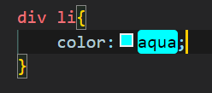

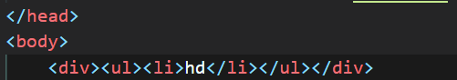

It has many more scenarios like div ul li { properties }

Child: It has jump only one step in one > sign is for child

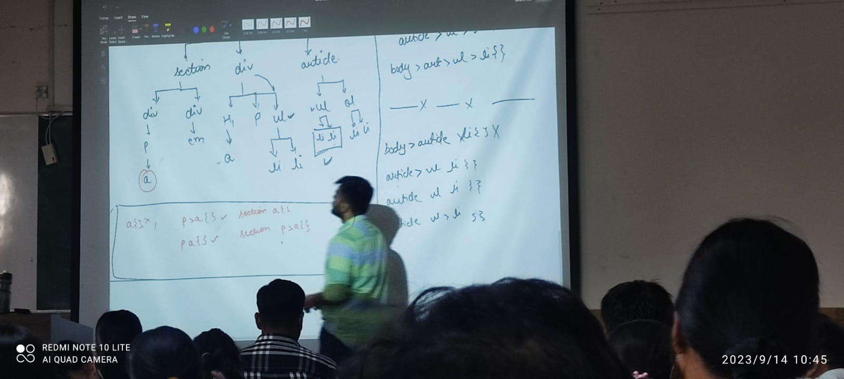

In the above child is described for a is like as

p>a{},p a{}, section a{} **section p>a{}** it is descdeant and child both because descendant can jump any step but child can jump only one step.

Adjacent sibling:

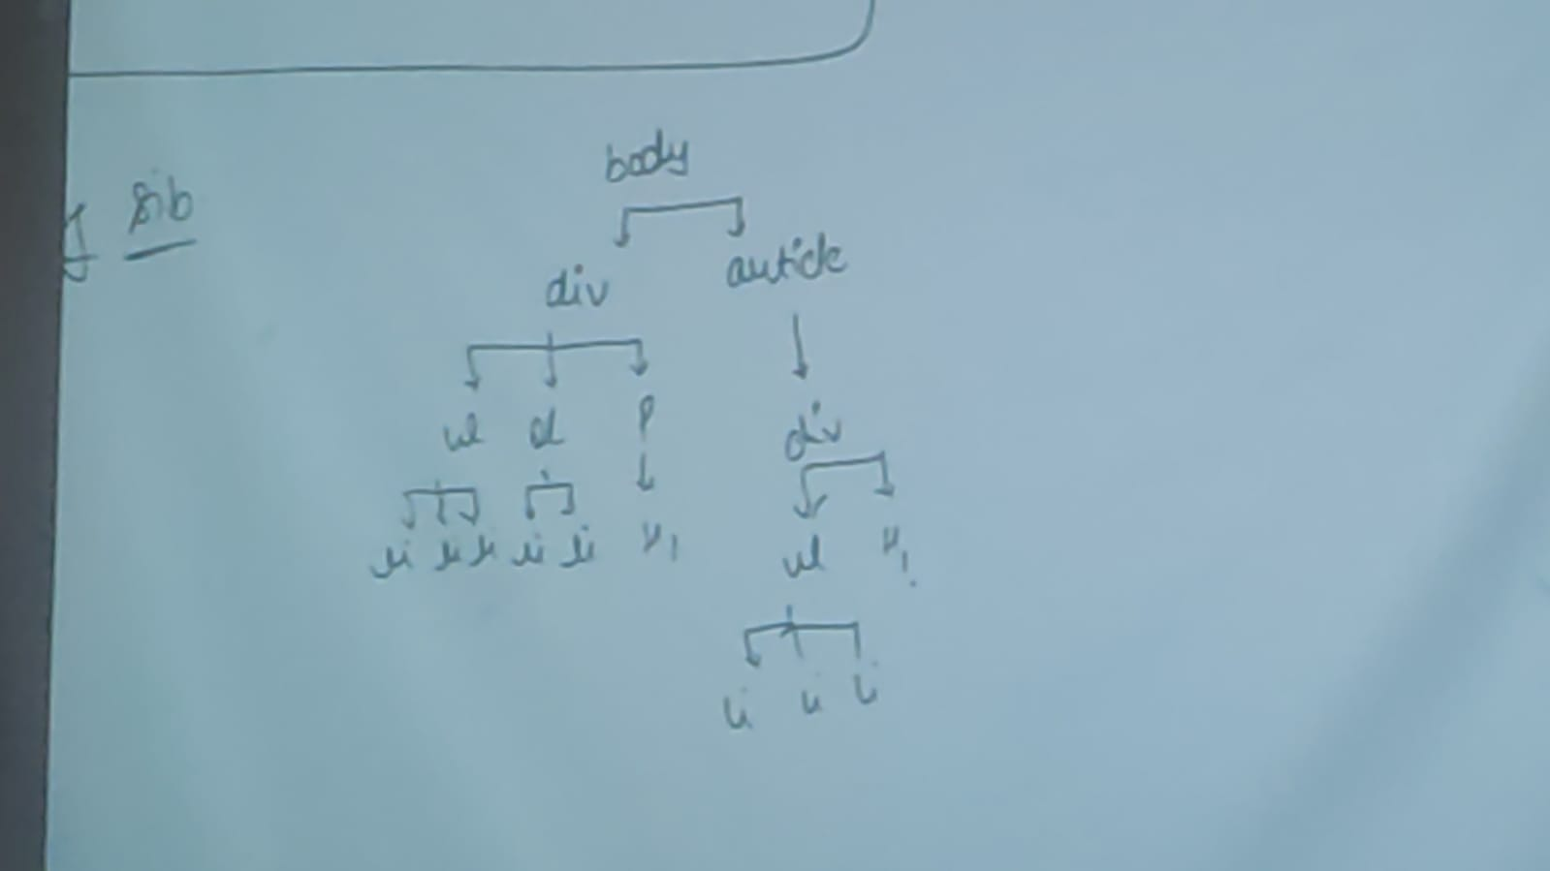

+ sign is for adjacent sibling

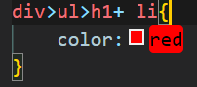

In Adjacent sibling code flow will be left to right and top to bottom and adjacent is always right Wala.

General sibling: sign will change to ~

div>ul>h1~li{

    color:red

}

In this we change all the sibling element after right.

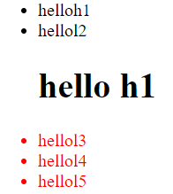

Pseudoclasses :

Hover is a function is which changes the properties of content when we move cursor to one state to other.

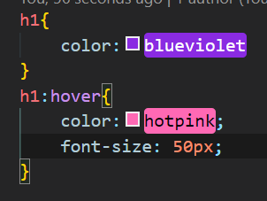

Hover,focus,active,visited

Psuedoelement: